# My Wellbeing Kit

Application User Guide

William Stephenson: Project Manager

Aidan Vos: Client Liaison

Changlai Zhao: Lead Programmer

Samuel Fahey: Lead Programmer

WenHao Wang: Testing Manager

Weibo Chen: Report Coordinator

Sa Ma: Marketing Coordinator

**My Wellbeing Kit** **1**

**1. Introduction** **4**

**2. Installation** **4**

2.1 Android 4

2.2 iOS 4

2.2 Application Icon 4

**3. Getting started (Menu and Navigation)** **5**

3.1 Android 5

3.2 iOS 5

**4. Main functionality** **6**

4.1 Wellbeing Cards 6

4.1.1 What are the cards used for 6

4.1.2 Writing on the back of cards 6

4.1.3 Favouriting cards 6

4.2.1 Adding Custom Cards 7

4.2.2 Duplicating Cards 7

4.2.2.1 Android 7

4.2.2.2 iOS 7

4.2.3 Deleting Cards 8

4.2.3.1 Android 8

4.2.3.2 iOS 8

4.3 Journal 8

4.3.1 What is the journal used for 8

4.3.2 Add a new journal entry 8

4.3.3 Editing journal entries 9

4.3.4 Deleting journal entries 9

4.3.4.1 Android 9

4.3.4.2 iOS 9

4.3.5 Filtering journal entries by category 9

4.4 Helpful Contacts 9

4.4.1 What is the Helpful Contacts for 9

4.4.2 Add a new Helpful Contact 9

4.4.3 Deleting and Editing the helpful contacts 10

4.4.3.1 Android 10

4.4.3.2 iOS 10

4.5 About the Kit 11

4.6 Privacy (Setting a Password) 11

4.6.1 What is the Password for 11

4.6.2 Create a Password 11

4.6.3 Disable Password 11

4.6.4 Forgotten Password 11

# 

# **1. Introduction**

The My Wellbeing Kit application has been developed by the University of Tasmania (UTAS) “My Wellbeing Kit” project development team in conjunction with the Live Clarence branch of the Clarence City Council (CCC). The application is designed to provide a digital alternative to the CCC’s existing My Wellbeing Kit; a physical set of 13 illustrated cards targeted at promoting mental wellbeing.

This user guide will walk through the main functionality of the My Wellbeing Kit application, providing a comprehensive understanding and overview of the application and its various features and components.

The application is compatible with both Android and IOS devices and is available on both Google Play and the Apple store respectively. Both applications are free to use and follow strict, platform determined User Interface (UI) guidelines. Our aim is to provide our users with a safe space in which an individual can self-regulate their mental health within a secure, private, accessible all in one application.

# **2. Installation**

## 2.1 Android

Users are able to install the Android application from the Google play store from their smart android devices.

The application is compatible with the device running Android 5.0 or higher. To find the My Wellbeing Kit application on the Google store simply search for ‘My Wellbeing Kit’. Tap the My Wellbeing Kit search result *[Icon of app attached]* and select the install button.

## 2.2 iOS

This application will be installed through the Apple App Store. To find the product, search for ‘My Wellbeing Kit’ and look for the entry with ‘Clarence City Council’ listed as the developer. Select this entry *[Icon of app]* then press the Get button to download the application. The application will then be launched by selecting its icon from the home screen of the device.

## 2.2 Application Icon

The application icon is designed by Shiloh Longbottom in conjunction with the desires of the CCC and provides a face and character for the application. 

# **3. Getting started (Menu and Navigation)**

After the Android application has been downloaded and installed it is able to be launched by selecting the Application Icon. The application does not require an internet connection to be launched and as such is accessible at any time from anywhere.

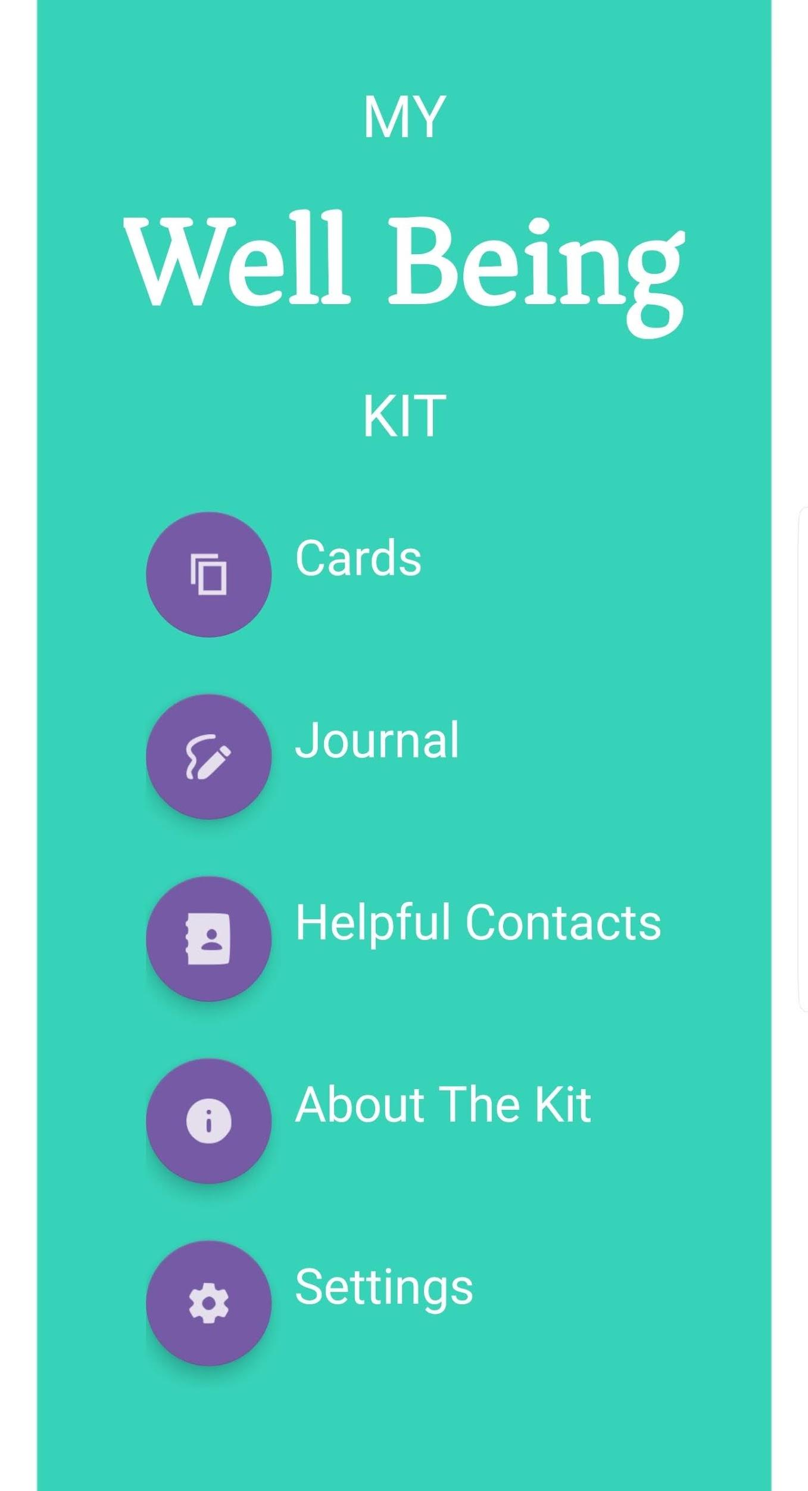

## 3.1 Android

Upon launching the application the menu screen will be displayed (Shown left). The main functionality of the application can be accessed from this menu: Cards (4.1, 4.2), My Journal (4.3), Helpful Contacts (4.4), About This App (4.5) and Settings (4.6). Moreover, each of the five functionalities can be reached through the blow out menu located at the bottom of each system interface.



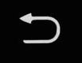 The user is able to select their desired screen through their selection of the showcased icons provided. Allowing for navigation between any of the other screen within the application. If the user wishes to retrace their steps from the current interface, simply clicking the (android) ‘back’ button to achieve this.

## 3.2 iOS

Upon launching the application the My Wellbeing Kit loading screen will be visible. After a few seconds of loading, the Cards screen will be presented. This is where the digital Wellbeing Cards can be accessed and used. For more information on this feature, see section 4.1.

The application presents four tabs at the bottom of the screen.



The tab highlighted purple is the tab that is currently selected. The tabs from left to right are: Cards (4.1, 4.2), Journal (4.3), Helpful Contacts (4.4), and Settings (4.5, 4.6).

Buttons controlling common actions that are performed on these screens (such as adding or editing items) can be found at the top left and right of each screen, on either side of the title of the page.

# **4. Main functionality**

The instructions for using and navigating each area of the application are outlined below.

## 4.1 Wellbeing Cards

### 4.1.1 What are the cards used for

The My Wellbeing Kit hosts a default set of 13 illustrated cards. Each cards depicts an image that will provide friendly representations of moments and situations everyone can relate to. When faced with these situations, the cards can be referred to for tips on what the individual finds helps them stay in, or achieve, a more positive headspace. These tips may be revisited, reviewed and revised at any time.

### 4.1.2 Writing on the back of cards

When a particular card evokes an emotion, thought or suggestion, it can be recorded on the back of a card. A simple **tap** will flip the card over, revealing a space for writing.  
Anything written on the back of the card will be saved and can be returned to at a later date to be added to, edited or deleted.

### 

### 4.1.3 Favouriting cards

If a card is being used a lot or is particularly helpful, it can be set as a ‘favourite’ card by **tapping** the heart icon present at the top right hand corner of all cards. Favourite cards will be moved to the front of the Wellbeing cards list, ensuring that the users preferred cards are presented first. **Tapping** this heart icon again will remove the card’s status as a favourite and return it to its original position in the list.

4.2 Wellbeing Custom Cards

The custom card functionality provides the user the ability to create their very own wellbeing cards. Custom cards are a way to preserve a moment or experiences. In addition to the base kit, custom cards will allow for the recording of unique experiences that will add to a users overall kit.

### 4.2.1 Adding Custom Cards

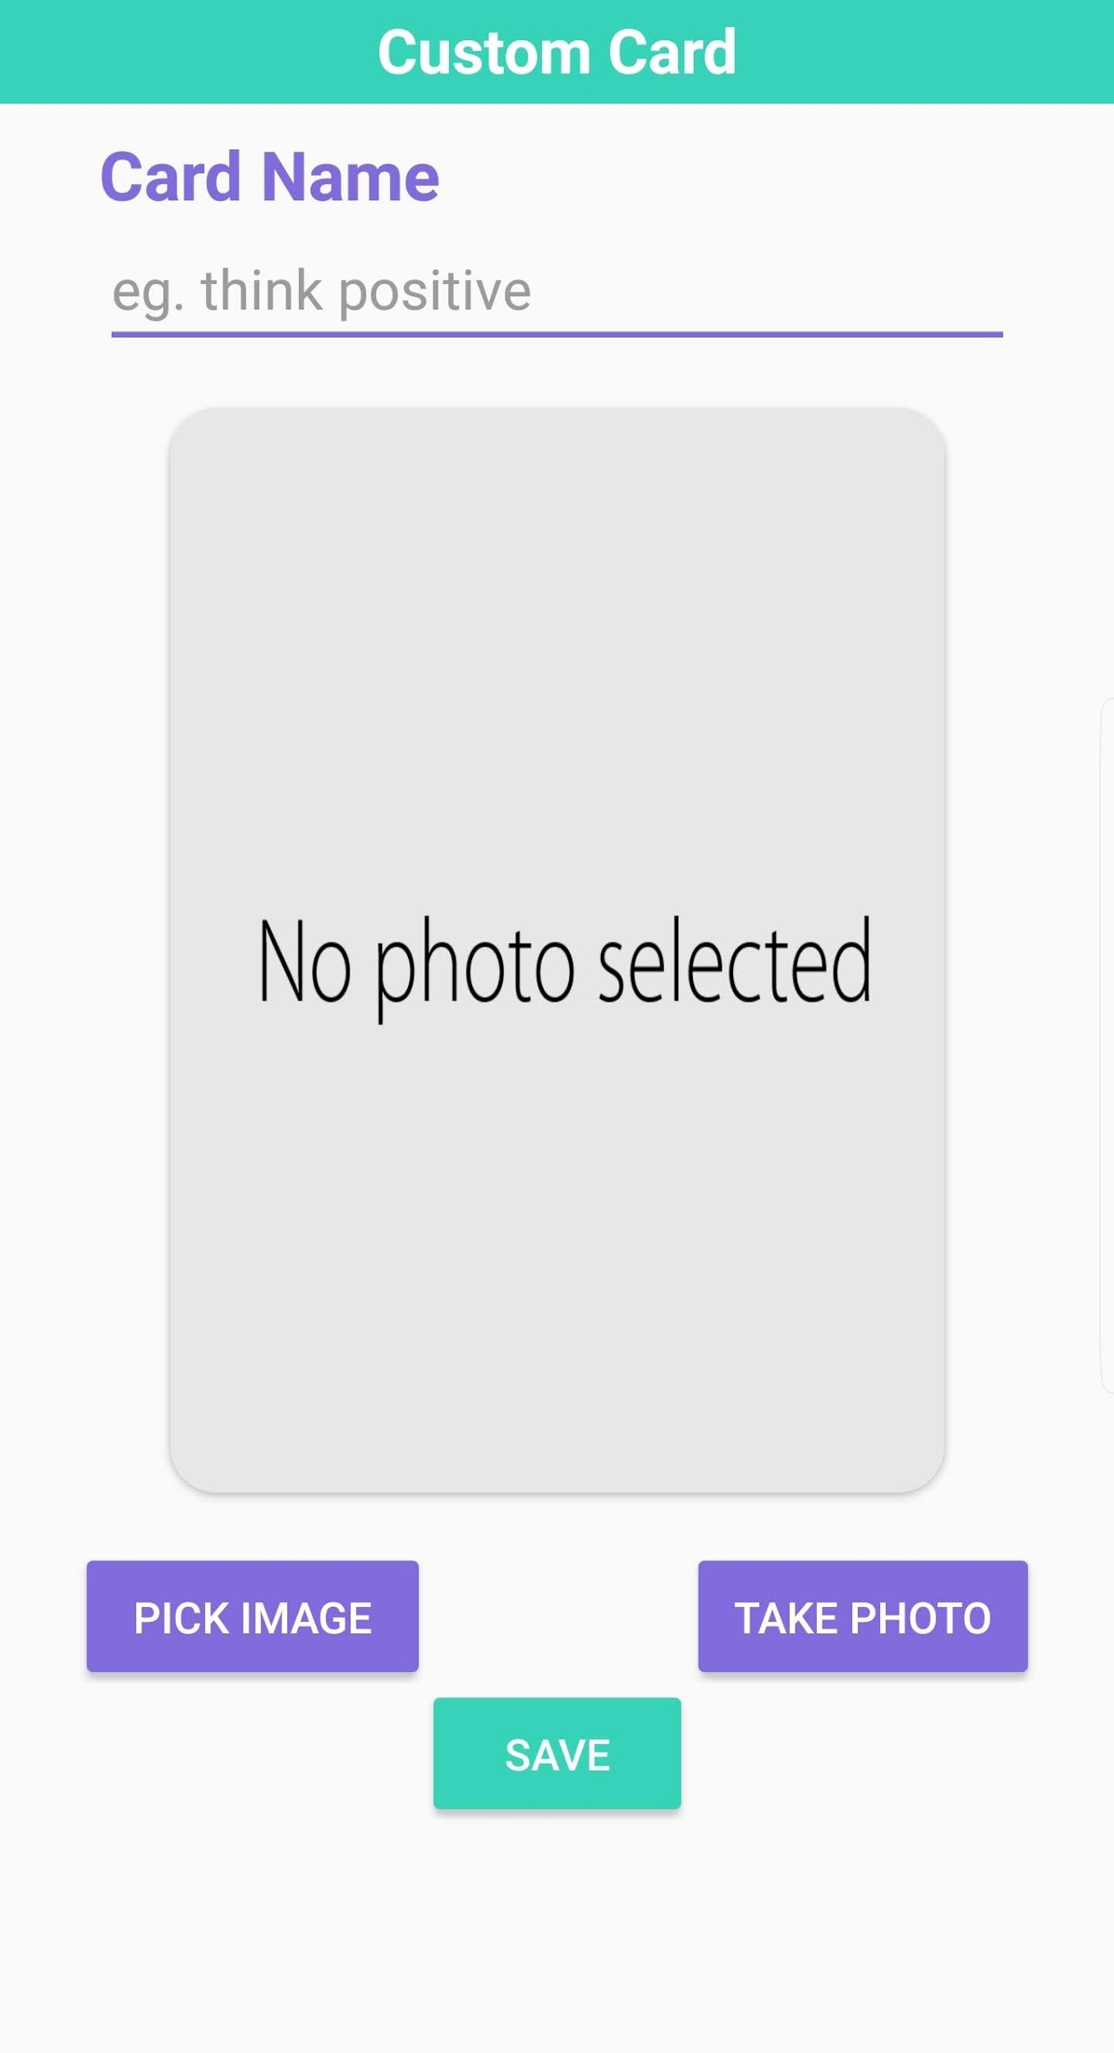In addition to the set of 13 cards that come pre-installed with the application, extra cards can be created. These cards can have custom titles and images.

When viewing the cards, simply select the plus button. This will open the ‘New Card’ screen. On this screen select the text box labelled ‘Card Name’ and type in the title of the card. There a two options for adding images to cards. A) Use and existing image and B) Take a photo to use.

1. To use an existing image, select the ‘Pick Image’ button. This will open up the phone’s photo storage. Selecting a photo from the phone will return the app to the New Card screen and show the selected image.
2. To take a new photo, select the ‘Take Photo’ button. This will open up the camera application. Once the user has taken a photo, the app will return to the New Card screen and show the photo taken.

Once both the name and image fields have been filled, select the ‘Save’ button located at the top right hand corner of the application. This will return the app to the cards menu, add the new card to your Wellbeing Cards and show the new card.

### 4.2.2 Duplicating Cards

#### 4.2.2.1 Android

To duplicate a card **long press** the desired card. This will bring up a menu from which ‘Delete’ and ‘Duplicate’ can be selected. Select the ‘Duplicate option, then select ‘Duplicate’. This will duplicate the card, place it at the end of the list of Wellbeing Cards and scroll the list to the end of the cards.

#### 4.2.2.2 iOS

To duplicate a card, select the ‘Edit’ button. This will toggle the Wellbeing Cards into edit mode. Select the ‘Duplicate’ button located to the right of the red trash icon, in the top left-hand corner of any card. This will duplicate the card, placing it at the end of the list of Wellbeing Cards. The application will scroll through the list of cards to the end where your card has been added. Once finished duplicating cards, toggle the edit mode off by selecting the ‘Done’ button at the top left-hand corner of the application.

### 4.2.3 Deleting Cards

#### 4.2.3.1 Android

To delete a card **long press** the desired card. This will bring up a menu from which ‘Delete’ and ‘Duplicate’ can be selected. Select the ‘Delete’ option, then select ‘Delete’. While custom cards may be deleted, the 13 default cards may not.

#### 4.2.3.2 iOS

To delete a card, select the ‘Edit’ button located in the top left-hand corner of the application. This will toggle the Wellbeing Cards into edit mode. Then select the ‘Delete’ button by pressing the red trash can icon located in the top left-hand corner of any card. This will delete the card from the Wellbeing Cards list. Once finished deleting cards, toggle the edit mode off by selecting the ‘Done’ button at the top left-hand corner of the application. While custom cards may be deleted, the 13 default cards may not.

## 4.3 Journal

### 4.3.1 What is the journal used for

The journal feature of the application is a space to save thoughts, moods and feelings in the form of a journal entry. The journal can be opened by selecting the Journal from the menu of the application.

### 4.3.2 Add a new journal entry

A journal entry can be created by clicking the plus icon button on the top right-hand side of the My Journal screen. This will bring up a new, empty entry with the current day’s date automatically in the date field.

Select a category by pressing the ‘Select Emotion’ button. This will bring up a table of emotions. To navigate these, select an overall category (Happy, Sad, Angry, etc). These will display more emotions related to that category. Selecting one of these emotions will return you to the previous screen.

Tap in the text box to begin entering text into the journal entry. Once this has been completed, tapping anywhere outside of the text box will let the application know you are done and enable the save button to be pressed. Pressing the save button will return the application to the My Journal page with the new entry visible in the journal.

### 4.3.3 Editing journal entries

To edit an existing journal entry, simply select it from the list of journal entries on the My Journal screen. This will open it up in the Edit Journal screen. From here all the fields can be edited in the same way as when creating a new entry (see 4.3.2). Selecting the ‘Cancel’ button will discard any changes made and return to the My Journal page. Pressing the save button will save all changes and return the application to the My Journal page with the edited entry visible in the journal. If any changes are made, the date field will be updated to the current date.

### 4.3.4 Deleting journal entries

#### 4.3.4.1 Android

To delete an entry **long press** it and then select the ‘Delete’ option. Select ‘Confirm’ to delete the entry or ‘Cancel’ to close the menu without deleting the entry.

#### 4.3.4.2 iOS

To delete a journal entry, swipe the journal entry from right to left. A light swipe will reveal the delete button which can then be selected. A hard swipe will select delete automatically. Either of these will bring up a confirmation menu, in which selecting ‘Delete’ will confirm the deletion, or ‘Cancel’ will close the menu and not delete the entry.

### 4.3.5 Filtering journal entries by category

To only show journal entries of a certain category, select the ‘Select Emotion’ text box at the top of the list. This will bring up a list containing any of the categories that are already in the journal. Selecting one of these will show journal entries of only that type. ‘All’ can also be selected to show all journal entries.

## 4.4 Helpful Contacts

### 4.4.1 What is the Helpful Contacts for

The Helpful Contacts area of the application that contains links to various external resources that may be helpful in supplementing the wellbeing provided by using the kit. Several of these come installed with the application but more can be added at any time.

### 4.4.2 Add a new Helpful Contact

To add an additional contact/resource, select the plus button. This will bring up a window in which text can be entered. Enter either a phone number or web address into this field and then select ‘Save’ to enter it into into the system or ‘Cancel’ to return without saving. After a new entry has been entered, it will appear under the heading ‘Links I Find Helpful’. If the entry is a phone number, selecting it will open the devices Phone application. If the entry is a website, selecting it will open the web browser.

### 4.4.3 Deleting and Editing the helpful contacts

#### 4.4.3.1 Android

The deleting function and editing function for helpful contacts is very much like the deleting and editing of journal entries (4.3.3 and 4.3.4). This system is base on the main helpful contacts page and can be achieved by long pressing the helpful contact that is to be deleted.

Selecting ‘Edit’ from the following dialogue box will bring up a text field where the entry can be adjusted. While selecting ‘Save will confirm the changes made. If ‘Cancel’ is selected the application will return without saving to the Helpful contacts page.  
Selecting ‘Delete’ will bring up a confirmation menu. Select ‘Delete’ to confirm the deletion or ‘Cancel’ to return without deleting anything.

#### 4.4.3.2 iOS

To delete or edit an entry, swipe the entry from right to left. A light swipe will reveal the edit and delete options while a hard swipe will automatically select delete.

Selecting ‘Edit’ will bring up a text field where the entry can be adjusted. Select ‘Save to confirm the changes or ‘Cancel’ to return without saving.

Selecting ‘Delete’ by light swiping and pressing the button or by hard swiping, will bring up a confirmation menu. Select ‘Delete’ to confirm the deletion or ‘Cancel’ to return without deleting anything.

## 4.5 About the Kit

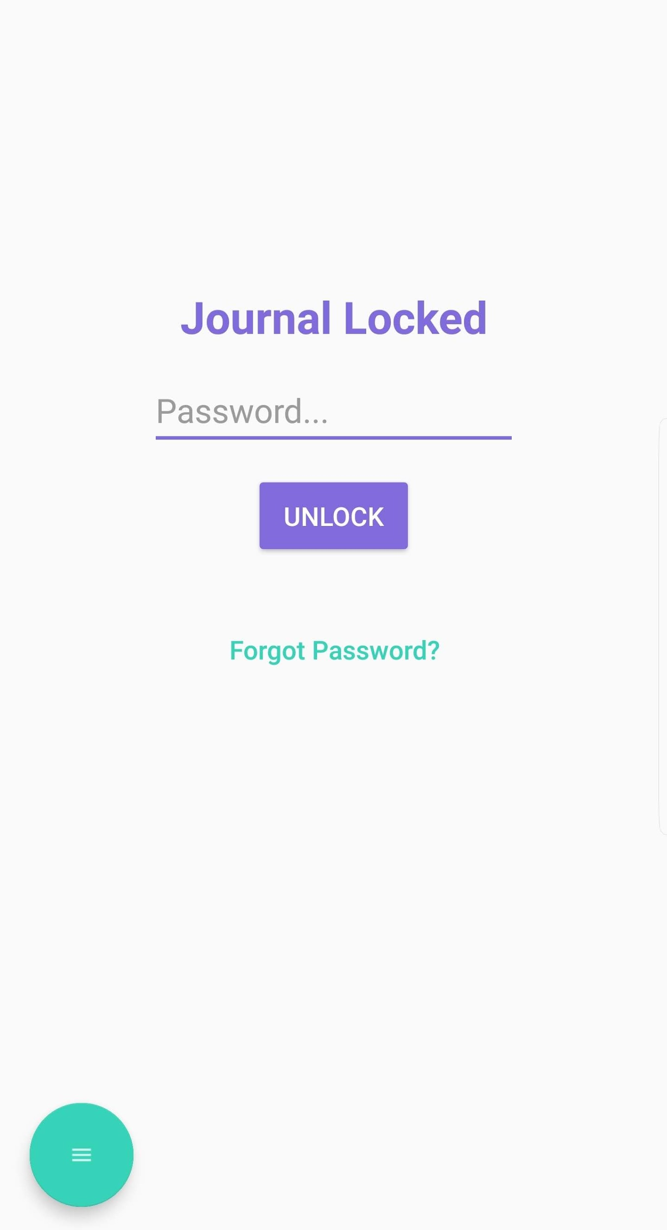This area of the application explains the intended use of the Wellbeing Kit as well as acknowledgements of the individuals and organisations that were involved in the creation of the project. There is also an email address that can be contacted for more information about the Wellbeing Kit.

## 4.6 Privacy (Setting a Password)

### 4.6.1 What is the Password for

Setting a password lets the user protect their journal by requiring a password to be entered before opening the journaling system. This feature is completely optional and only needs to be used if privacy is a concern.

### 4.6.2 Create a Password

To set a password for the journal, navigate to the settings menu and toggle the ‘Journal Password Lock’ on to. This will open a form in which the user must enter, and confirm their password. There is also a security question which must be set and answered which can be used to reset the password if it is forgotten. Once these have been filled out, select ‘Save’ to confirm the new password or ‘Cancel’ to cancel and toggle off the password.

### 4.6.3 Disable Password

To disable the password, toggle off the ‘Journal Password Lock’ option in the settings menu. This will prompt for the password to be entered. Enter the current password and select ‘Confirm’ to disable the password.

### 4.6.4 Forgotten Password

Should the password be forgotten, select the ‘Forgot Password?’ option in the Journal Locked screen. This will display the security question and provide space to answer the question. Type the correct answer and press ‘Submit’. This will give access to a screen where a new password and security question can be set.